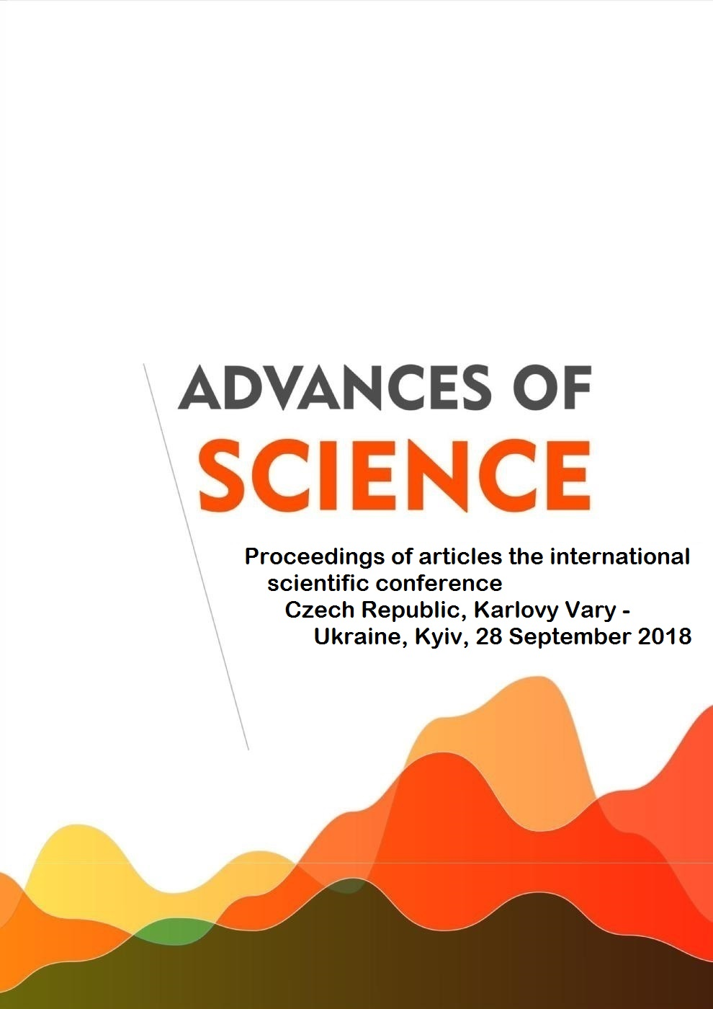

UDC 001

BBK 72

D728

Scientific editors:

Katjuhin Lev Nikolaevich, Doctor of Biological, a leading researcher at the Institute of Evolutionary Physiology and Biochemistry named I.M.Sechenov Academy of Sciences

Salov Igor' Arkad'evich, Doctor of Medical, Head of the Department of Obstetrics and Gynecology, Saratov State Medical University named V.I.Razumovskij

Danilova Irina Sergeevna, Ph.D., Associate Professor of Tomsk State Pedagogical University named L.N.Tolstoj Burina Natal'ja Sergeevna, Ph.D., Associate Professor of Nizhny Novgorod State named University N.I. Lobachevskij

^{D728} ADVANCES OF SCIENCE: Proceedings of articles the international scientific conference. Czech Republic, Karlovy Vary – Ukraine, Kyiv, 28 September 2018 [Electronic resource] / Editors prof. L.N. Katjuhin, I.A. Salov, I.S. Danilova, N.S. Burina. – Electron. txt. d. (1 файл 18,7 MB). – Czech Republic, Karlovy Vary: Skleněný Můstek – Ukraine, Kyiv: MCNIP, 2018.

– ISBN 978-80-7534-078-8.

Proceedings includes materials of the international scientific conference « ADVANCES OF SCIENCE», held in Czech Republic, Karlovy Vary-Ukraine, Kyiv, 28 September 2018. The main objective of the conference - the development community of scholars and practitioners in various fields of science. Conference was attended by scientists and experts from Azerbaijan, Russia, Ukraine. At the conference held e-Conference "Perspectives of science and education". International scientific conference was supported by the publishing house of the International Centre of research projects.

ISBN 978-80-7534-078-8 (Skleněný Můstek, Karlovy Vary, Czech Republic)

Articles are published in author's edition. Editorial opinion may not coincide with the views of the authors

Reproduction of any materials collection is carried out to resolve the editorial board

© Skleněný Můstek, 2018
СЕМЧИШИНА.-М. С. СУТЬ ОСОБИСТІСНО-ОРІЄНТОВАНОГО ПІДХОДУ ДО ДИТИНИ В НАВЧАЛЬНО-ВИХОВНОМУ ПРОЦЕСІ ДОШКІЛЬНОГО НАВЧАЛЬНОГО ЗАКЛАДУ. | 1205
АРМАШ Т. С. РОЗВИТОК АЛГОРИТМІЧНИХ КОМПЕТЕНТНОСТЕЙ МАЙБУТНІХ УЧИТЕЛІВ МАТЕМАТИКИ ПІД ЧАС ВИВЧЕННЯ ЛІНІЙНОЇ АЛГЕБРИ. | 1212
KIRYEV I.V., ZHABOTYNSKA N.V. EXPERIENCE OF THE APPLICATION OF VISUAL TEACHING METHODS FOR STUDENTS OF THE NATIONAL PHARMACEUTICAL UNIVERSITY. | 1221
Трус О. М., прокопенко Е. В. вплив тривалого удобрення в польовій сівозміні на біологічну активність ґрунту. | 1224
РОМАНОВА З.М., РУБАН В.В., МАТВІЄНКО В.І. ДОСЛІДЖЕННЯ СТІЙКОСТІ ПИВА. | 1233
ЗАГОРОДНЯ Л.П. ЗМІСТ ПРАКТИЧНОЇ ПІДГОТОВКИ МАГІСТРАНТІВ ДО ЗАБЕЗПЕЧЕННЯ ЯКОСТІ ОСВІТНЬОГО ПРОЦЕСУ В ДОШКІЛЬНОМУ ЗАКЛАДІ. | 1236
Скляр О.Г., Скляр Р.В. Аналіз органічних добрив після анаеробної ферментацІЇ. | 1246
НЕСПЛЯК О.С., БАБЕЧКО О.Я. ФЛОРА ПРИДОРОЖНІХ ТЕРИТОРІЙ М. ІВАНО-ФРАНКІВСЬК. | 1254
БІЛЬДЕР Н.Т. ШЛЯХИ ОСОБИСТІСНОЇ ТА ПРОФЕСІЙНОЇ САМОІДЕНТИФІКАЦІЇ СТУДЕНТІВ-ДИЗАЙНЕРІВ. | 1258
МУДРАК Т.О., КУЦ А.М., КОВАЛЬЧУК С.С., КИРИЛЕНКО Р.Г. ОПТИМІЗАЦІЯ ТЕХНОЛОГІЇ ЗБРОДЖУВАННЯ ВИСОКОНЦЕНТРОВАНОГО СУСЛА ІЗ КРОХМАЛЕВМІСНОЇ СИРОВИНИ. | 1268
PASYEKA M., PASYEKA N., S. DANYLIUK, METHODS FOR ASSESSING THE CURRICULUM REGARDING INFORMATION TECHNOLOGY. | 1275
Храбатин Р.І., Бандура В.В., Саманів Л.В., Козак О.Ф., Храбатин О.В. Адаптивний інтелектуальний програмний додаток на основі штучного інтелекту для керування оптичною системою промислової сонячної електростанції. | 1284
АНТОНОВА В.Ю. СОЦІОКУЛЬТУРНА ТРАНСФОРМАЦІЯ БУТТЯ УКРАЇНСЬКОГО ЕТНОСУ В УМОВАХ ФОРМУВАННЯ ЄВРОПЕЙСЬКОЇ КУЛЬТУРНОЇ ІДЕНТИЧНОСТІ. | 1295
ЧЕРНОВА К.Ю., СТАНІСЛАВЧУК О.В. СТВОРЕННЯ ІНТЕРАКТИВНОГО ІНФОРМАЦІЙНОГО СЕРЕДОВИЩА ДЛЯ ПІДВИЩЕННЯ РІВНЯ ПІДГОТОВКИСПЕЦІАЛІСТІВ У ГАЛУЗІ ОХОРОНИ ПРАЦІ. | 1305
ОРДІНА Л.Л. СОЦІОКУЛЬТУРНИЙ АСПЕКТ ПОНЯТТЯ КУЛЬТУРОТВОРЧОСТІ У ПЕДАГОГІЦІ. | 1312
EXPERIENCE OF THE APPLICATION OF VISUAL TEACHING METHODS FOR STUDENTS OF THE NATIONAL PHARMACEUTICAL UNIVERSITY

KIRYEV I.V.

MD, Chairman of the Department of Pharmacotherapy

ZHABOTYNSKA N.V.

PhD, Associate Professor, Department of Pharmacotherapy

National University of Pharmacy
Kharkov, Ukraine

Visual teaching methods are used in order to implement the didactic principle of visibility in teaching [1]. Among the visual teaching methods, one of the most common is the method of presentation, which is divided into illustration and demonstration [2, 3]. The choice of this or that type of visual material depends on the purpose of the class, the level of development and basic knowledge of the students, on the content of the material and the possibilities of using one or another visually [2, 3].
Discipline "First pre-medical aid" is taught at the Department of Pharmacotherapy of the National Pharmaceutical University for students of the 2nd year of the specialty "Pharmacy" of various educational programs. The peculiarity of the "First pre-medical aid"is its practical orientation.
Students, after studying this discipline, should be able to provide first aid in terms of terminal conditions, shock, wounds and bleeding, burns and frostbites, various traumas, urgent conditions in surgical and therapeutic diseases, poisoning, sudden births, etc. The development of such skills requires the obligatory application of visual teaching methods with further practical training. Using the display method facilitates the perception of learning material, focuses on students and constantly supports it on the subject of the show.

The purpose of our work is to report on the application of visual teaching methods during the teaching of the discipline "First pre-medical aid" at the Department of Pharmacotherapy at National University of Pharmacy.
According to the methodological recommendations for organizing practical classes, visual material is mainly used in the third stage of the class, when the development of practical skills and skills and the consolidation of the studied material. To optimize the use of visual materials, the teacher provided a list of practical skills that need to be worked out at every practical lesson.
The teacher personally demonstrates the implementation of the practical skills provided by the topic of the lesson, using dummies ("buttocks", "upper extremities", "head", etc.) and other visual materials (bandages, hemostatic tourniquets, automotive first aid kit, AMBU bag, etc.).
All the necessary visual materials are collected in special boxes, which are marketed according to the topic of the lesson and have a description of the objects that are in them. If you cannot demonstrate practical skills as a teacher, video materials obtained from the official website of the Ministry of Health of Ukraine are used. For demonstration of video films, all teaching classes at the Department of Pharmacotherapy are equipped with multimedia projectors, and the teacher uses a computer (laptop) in a practical lesson, which provides optimal conditions for observation of visual materials for all students.It should be noted that during the demonstration of both practical skills and video, the teacher accompanies the presentation of an explanation, a story, focuses the attention of students on the main, helps to highlight the important aspects of the topic being studied. After demonstrating practical skills, the teacher has the opportunity to independently work out the practical skills seen in such a way that he can, if necessary, recreate them in practice.
At the Department of Pharmacotherapy, visual teaching methods are used in teaching the discipline "First pre-medical aid ". The use of the display method, mainly in the form of a demonstration in the educational process, during the study of the discipline "First pre-medical aid" increases the motivation of students, activates their mental activity, promotes the formation of specific skills, helps to understand the connection between practical classes in discipline and further professional activities.

USEDLITERATURE.

Malafiik I. V. Dydaktyka: navch. рosibnyk / I. V. Malafiik – K.: Kondor, 2009. — 406 Р.

Teaching method in high school: textbook / O. V. Malikhin, I. G. Pavlenko, A. O. Lavrent'ev, G. I. Matukova. – Simferopol: Daifi, 2011. – 270 p.

Kuzminsky A. I. Pedagogics: textbook / A. I.Kuzminsky, V. L. Omelyanenko. – K.: Znannya, 2007. –447 p.

